Prep Instructions
Name: ______________________________________ Date: _____________________________

Doctor: ______________________________________ Time: _____________________________

*Failure to comply with these instructions may result in a cancellation of your procedure.
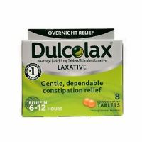
**You will need to purchase one (1) box of Dulcolax Laxative tablets (8 counts) and two (2) fleet enemas. The products can be purchased at any Walmart or drugstore.
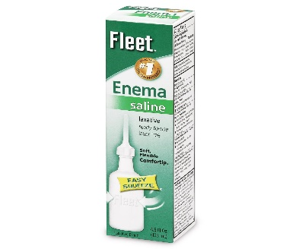

Instructions for Prep
- If you take any NSAIDs (ex., Ibuprofen, Aleve, Naproxen) or blood thinners such as Coumadin, Plavix, Pradaxa, Xarelto, Cilostazol, Aggrenox, Eliquis, ask your physician for additional instructions for possibly stopping medications before the colonoscopy procedure.
- Two days before the procedure: No fiber, No raw fruits or vegetables, No salads, or nuts.
- Day before the procedure:
- Clear liquids only. NO solid foods. NO milk or milk products. NO red or purple liquids. NO vegetable juice or juice with pulp.
- Examples of clear liquids- Water, Gatorade, Powerade, Apple juice, White grape juice, Tea, Soft drinks, Jell-O, popsicles, black coffee (may add sugar or sweetener), bouillon cubes dissolved in water, Lemonade, and Crystal light.
- Drink at least three (3) eight (8) ounces of clear liquids during the day. You may drink more if you desire.
- At 5:00 pm take two (2) Dulcolax tablets with eight (8) ounces of clear liquid
- At 8:00 pm administer one (1) Fleet enema.
- Nothing to eat or drink after midnight.

Day of procedure
- Administer one (1) Fleet enema two (2) hours before leaving home for your procedure.
- You will be sedated for the test and MUST have someone drive you home. If no one accompanies you as your driver, the procedure cannot be performed and will be rescheduled. Your driver must remain on the premises during your procedure. Public transportation (taxi, bus, uber driver, etc.) cannot be used.
- If you take blood pressure, thyroid, seizure, or diabetic medication, please take it with only a small sip of water the morning of your procedure.
- You are not permitted to drive, drink alcohol, operate machinery, or sign any legal documents the entire day of your test due to the sedation you will receive.
- Do NOT use smokeless tobacco, chew gum, or any mints/candy the morning of your procedure.
- Do NOT wear any jewelry or bring any valuables.
- Wear comfortable clothes. Colon preparation can affect everyone differently, so you may want to bring an extra set of clothes and a towel with you in case of any accidents, especially if you are traveling a long distance.
- You are not permitted to drive, drink alcohol, operate machinery, or sign any legal documents the entire day of your test due to the sedation you will receive.
- Plan to be at the facility for about 2-3 hours, depending on the preparation, procedure, and recovery time. Plan on taking the entire day off work, school, etc.
- Please provide 72-hour notice if you wish to cancel or reschedule your procedure to avoid a cancellation fee.

- If you have questions about your procedure instructions, don’t hesitate to contact your physician’s nurse by calling the number below.

Dr. Angtuaco- 501-406-9291 Dr. Coppola- 501-406-9301 Dr. Coggins- 501-406-9337
Dr. Hughes- 501-406-9311 Dr. S. Jones- 501-406-9321 Dr. J. Jones- 501-406-9302
Dr. McElreath- 501-406-9331 Dr. Patel- 501-406-9341 Dr. Svoboda- 501-406-9351

SURGERY CENTER
10915 N. Rodney Parham
Little Rock, AR 72212

Phone: 501-747-2828

